МИНИСТЕРСТВО ОБРАЗОВАНИЯ И НАУКИ РЕСПУБЛИКИ БЕЛАРУСЬ

БЕЛОРУССКИЙ НАЦИОНАЛЬНЫЙ ТЕХНИЧЕСКИЙ УНИВЕРСИТЕТ

## Факультет информационных технологий и робототехники

­

Кафедра программного обеспечения информационных систем и технологий

**Отчет по лабораторной работе № 01**

по дисциплине: ”Базы данных”

на тему: *”****Создание запросов на выборку .*** *”*

Вариант 05

Выполнил**:** студент группы 10720119 Кислицин Д.А.

Приняла**:** Воронич Л.В

Минск 2019

***Лабораторная работа №1***

***Создание базы данных в СУБД SQL Server.***

Ц**ель работы:**

**пр*иобретение практических навыков создания базы данных в СУБД SQL Server.***

***Краткие теоретические сведения.***

***Servic Manager. Для каждой базы данных SQL Server создает две файла: один для объектов, а другой для журнала транзакций (операций).***

*create table Cars(*

*carId int not null primary key auto_increment,*

*modelCode int,*

*releaseYear int,*

*carNum int*

*);*

*create table Drivers(*

*driverId int not null primary key auto_increment,*

*driverName text,*

*driverSurname text,*

*driverCode int,*

*driverDOB text*

*);*

*create table Models(*

*modelId int not null primary key auto_increment,*

*modelName text,*

*payloadCapacity int);*

*create table Report(*

*travelId int primary key auto_increment,*

*carId int not null,*

*driverId int not null,*

*dateOfExport text not null,*

*timeOfExport time,*

*cargoWeight int,*

*returnDate text not null,*

*foreign key (carId) references Cars(carId),*

*foreign key (driverId) references Drivers(driverId)*

*);*

*insert into Models (modelName, payloadCapacity)*

*value ("Tesla Model X", 100);*

*insert into Models (modelName, payloadCapacity)*

*value ("Tesla Model A", 1000);*

*insert into Models (modelName, payloadCapacity)*

*value ("Tesla Model B", 1233);*

*insert into Models (modelName, payloadCapacity)*

*value ("Tesla Model C", 1245);*

*insert into Models (modelName, payloadCapacity)*

*value ("Tesla Model Y", 4666);*

*insert into Models (modelName, payloadCapacity)*

*value ("Tesla Model Z", 41414);*

*insert into Drivers (driverName, driverSurname, driverCode, driverDOB)*

*values ("John", "Wake", 228, '05-06-2002');*

*insert into Drivers (driverName, driverSurname, driverCode, driverDOB)*

*values ("Kill", "Real", 228, "08-07-2003");*

*insert into Drivers (driverName, driverSurname, driverCode, driverDOB)*

*values ("Dan", "Equal", 228, "09-01-2005");*

*insert into Drivers (driverName, driverSurname, driverCode, driverDOB)*

*values ("Hill", "Syl", 228, "25-08-2007");*

*insert into Drivers (driverName, driverSurname, driverCode, driverDOB)*

*values ("Title", "Leak", 228, "14-12-2008");*

*insert into Drivers (driverName, driverSurname, driverCode, driverDOB)*

*values ("Json", "Xml", 228, "17-11-2010");*

*insert into Drivers (driverName, driverSurname, driverCode, driverDOB)*

*values ("Billy", "Meal", 228, "12-10-2021");*

*insert into Cars (modelCode, releaseYear, carNum)*

*values (228, 2002, 0);*

*insert into Cars (modelCode, releaseYear, carNum)*

*values (213, 2003, 1);*

*insert into Cars (modelCode, releaseYear, carNum)*

*values (5454, 2010, 2);*

*insert into Cars (modelCode, releaseYear, carNum)*

*values (246, 2077, 3);*

*insert into Cars (modelCode, releaseYear, carNum)*

*values (246, 2077, 3);*

*insert into Cars (modelCode, releaseYear, carNum)*

*values (246, 2077, 3);*

*insert into Cars (modelCode, releaseYear, carNum)*

*values (246, 2077, 3);*

*insert into Report (carId, driverId, dateOfExport, timeOfExport, cargoWeight, returnDate)*

*values (1, 1, "02-02-2021", "15:00", 50, "05-02-2021");*

*insert into Report (carId, driverId, dateOfExport, timeOfExport, cargoWeight, returnDate)*

*values (1, 4, "04-02-2021", "15:00", 150, "10-02-2021");*

*insert into Report (carId, driverId, dateOfExport, timeOfExport, cargoWeight, returnDate)*

*values (2, 1, "02-02-2021", "15:00", 200, "05-03-2021");*

*insert into Report (carId, driverId, dateOfExport, timeOfExport, cargoWeight, returnDate)*

*values (3, 1, "10-03-2021", "15:00", 170, "14-04-2021");*

*insert into Report (carId, driverId, dateOfExport, timeOfExport, cargoWeight, returnDate)*

*values (1, 4, "01-05-2021", "15:00", 200, "05-08-2021");*

*insert into Report (carId, driverId, dateOfExport, timeOfExport, cargoWeight, returnDate)*

*values (3, 2, "04-07-2021", "15:00", 1000, "16-08-2021");*

*insert into Report (carId, driverId, dateOfExport, timeOfExport, cargoWeight, returnDate)*

*values (1, 1, "08-07-2021", "15:00", 300, "20-09-2021");*

*insert into Report (carId, driverId, dateOfExport, timeOfExport, cargoWeight, returnDate)*

*values (2, 2, "01-09-2021", "15:00", 200, "21-10-2021");*

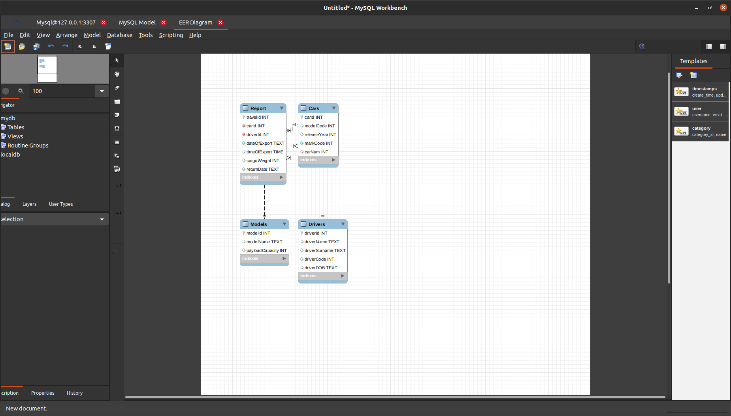

**~~Контрольные вопросы:~~**

**~~1. Каким требованиям должна удовлетворять таблица реляционной базы данных?~~**

**~~2. Какие типы данных предназначены для описания целочисленных значений полей?~~**

**~~3. Что такое первичный и внешний ключи таблицы?~~**

**~~4. Как и для чего устанавливаются связи между таблицами?~~**

**~~5. Чем отличаются типы данных char, nchar, varchar, nvarchar?~~**